Lesson plan 2: Designing a leaflet
About the lesson
This lesson provides students with an opportunity to develop their word-processing skills while at the same time considering how to use all the formatting tools at their disposal to create a well-designed document.
Learning objectives
By the end of this lesson, students will:
- have taught themselves to use a range of word-processing tools
- understand the design cycle
- be able to create a well-designed leaflet using word-processing software.
National Curriculum
The following subject content from the KS3 National Curriculum is included in this lesson:
- Understand the software components that make up computer systems.
- Undertake creative projects that involve selecting, using and combining multiple applications.
Links
The skills explored to create leaflets in a word processor will be useful throughout the course and in many other subject areas.
Key terminology
word-processing software, user interface (UI), design cycle
Teaching and learning activities
Share the objectives for the lesson with students (Slide 2 of Lesson 2 presentation).
Starter
Draw a parallel between the first commercial word-processing application, WordStar, and modern word-processing applications (Slide 3 and page 32).
Introduce students to the most commonly used word-processing commands (Slide 4 and page 32).
Show students how to find out how to do things they don't know how to do (Slides 5–6 and page 32).
Part 1
Ask the students to complete Activity 2.1: Word-processing skills (Worksheet 2.1, slide 7).

Some or all of the tasks may be unfamiliar to students. Tell students who ask for help that they should use the strategies they have been taught to work out how to complete each task for themselves. The activity could be done as a paired activity to enable students to share their knowledge.
Answers
The edited and formatted document should look like this:
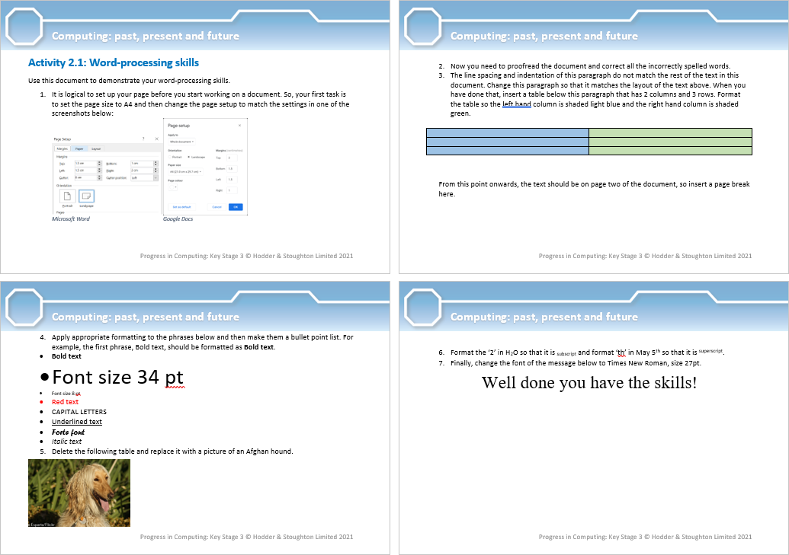
Part 2
Explain to students that they are going to design a leaflet but, before they do, you are going to introduce them to the design cycle (Slide 8 and page 32).
There are many versions of the iterative design cycle and the students may have come across something similar before. The key point to emphasise is that following a circular, iterative (repeating) approach to design, rather than a linear approach, allows for the fact that a design is rarely perfect first-time around and it will need to be tested and improvements will need to be made. The design cycle does not need to be repeated a set number of times but, each time it is repeated, the design should improve until, eventually, it is fit for purpose and no more improvements are required.
Ask students to complete Activity 2.2: Planning and creating a leaflet (Worksheet 2.2, slide 9).

- You will need to decide what cause or event the leaflet should publicise before the lesson. Ideally, it should be something students will directly relate to and, ideally, should serve a real purpose. Could students create leaflets for an in-school recycling campaign or the school sports day, for example? You could even supply students with the text and any images for the leaflet.
- The tips provided on Worksheet 2.2 could serve as assessment criteria, if you would like to formally assess students' work.
Ask students to complete Activity 2.3: Commenting on your partner's leaflet (Slide 10).
This is stage 4 of the design cycle: test your solution (on the audience if possible).
Plenary
Ask students to complete Quiz 2 (Slide 11).
Homework
Ask students to complete Activity 2.4 Finishing creating your leaflet (Slide 12).
This is the rest of stage 4 of the design cycle: evaluate your solution. It is also stage 5: if improvements are needed, work through the cycle for the second time. And, hopefully, work round to stage 6: finish. Students may want to test their solution with friends and family and make further improvements though, looping through the design cycle again.
Stretch activities
Some students may be familiar with the software and happy to explore a range of features. They should be encouraged to experiment with these features and explore the range of templates available with the package.
Support activities
To support students who find this task difficult supply the text and images and further examples of simple leaflets so that they can copy the style. They should concentrate on achieving a simple but effective result using a small range of features.

